Application to Join Ice Warrior’s #Lastpole Expedition
The Biggest, Boldest, Bravest and Most Important Expedition of Our Time
The Last True World First and Crucial Citizen Science

Many thanks for your interest – it’s people like you who are the essence of Ice Warrior.

Background
The Northern Pole of Inaccessibility remains the last significant place on earth, as yet, unreached by humankind. By definition, it is the furthest point from land on the Arctic Ocean (the very centre) and over 270 miles from the Geographic North Pole.

The expedition, subject to the level of funding required, is set to start in mid February and finish in May 2023. The journey is an 800-mile, 80-day expedition, divided into 4 legs of 20 days and team members are being sought for each of the legs.

You will take part in a fully comprehensive training programme that will ensure all participants are safe and competent polar travellers, gaining skills that are really useful in both business and life in general.

Throughout the transect and under the guidance of the world’s leading scientific authorities, we will be gathering brand-new scientific data to document the condition of the Arctic Ocean and establish a benchmark for scientists to compare year-on-year. We will be extending our knowledge of this crucial region. The rationale being, if we are not monitoring the state of the Polar Regions how will we know if anything we are doing in our own back gardens to mitigate climate change is actually working?

What am I looking for?
I am looking for decent, courageous, determined, dedicated, kind and loyal people with the right positive attitude and commitment, who have enough time to put in the effort required to do this. Aged from 18 upwards and you do not need previous outdoor experience.
It’s not easy. If it was, lots of people would be doing it and the pole would have been reached by now.
I’m not looking for experts as every aspect of becoming a modern-day polar explorer is covered within the training process.
You can start as a complete novice to outdoor activities.
Or, have some existing skills, which I will assess, and build your path to polar competence.
If you’re interested in joining me please complete the details below – answer the two questions and send them back to me in an email.

If you are accepted and happy to proceed the next step is to book onto the training.

Your Commitment to Ice Warrior – You will:
- Engage with and promote all the aims and aspirations of the Ice Warrior Project
- Dedicate yourself – time and effort - to Ice Warrior and #Lastpole and reach competence during the training and development process – see below
- Take an integral role within the training squad and the final expedition team
- Undertake at least a 20 day leg of the 80 day expedition (on ice) – allowing for 26 days away
- Make every effort, from the outset, to raise £12,000 through sponsorship, as your contribution towards the expedition budget and understand if you do not reach this level you might well be dropped from the Ice Team
- Ensure you are fit and healthy enough to undertake both the training and the endeavour (you will be asked to sign a medical disclaimer)
- Be happy to be a subject of the Feature Documentary telling the tale of your own story and that of our endeavour (there is a separate Film Release Form in this respect)
Please Note: This is not an Adventure Holiday and therefore don’t expect things to go to plan in a timely fashion. For reasons of expediency and progress, I reserve the right to change the plan and timings, throughout. A positive and flexible attitude is required.

My Commitment to You – I will:
- Lead you in this endeavour, bringing to bare my 36 years of polar experience and over 40 years of expeditioning
- Dedicate my time (and that of my hugely experienced staff) and effort to ensure:
  - you reach the status of being a competent polar explorer (if at all possible)
  - you have the skills, materials and support to raise the funds necessary for your participation – Total of £25 k
- Provide you with all the kit and clothing required to achieve this at highly discounted rates (included in above figures)
- Wholly support and help your application to your employer, to take part in this historic endeavour
- Be available at all times to support you in this endeavour

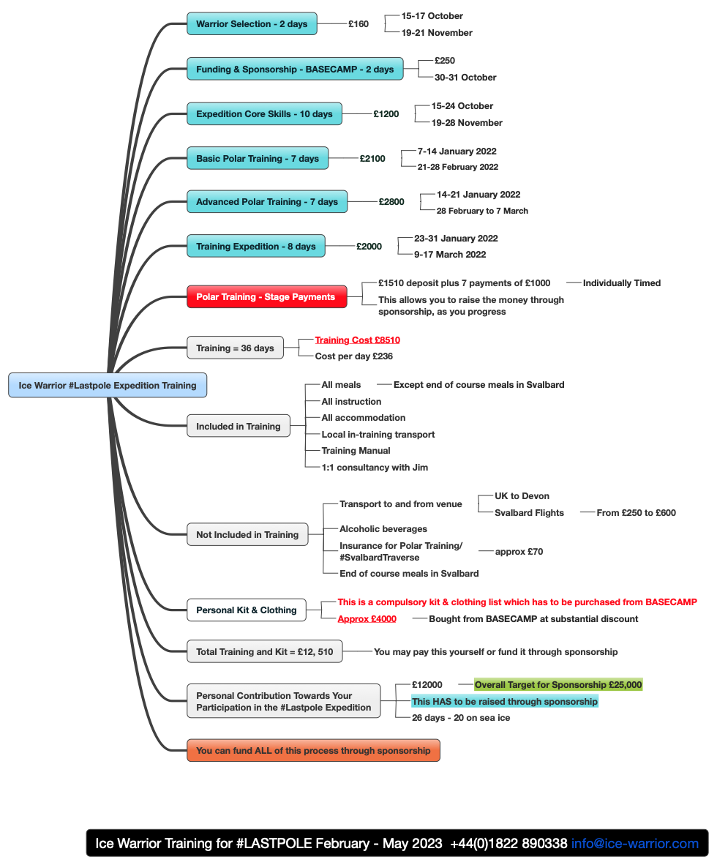
Training Dates and Costs (You can recoup)
1 x 20-day leg of the expedition between Mid-February and Mid-May
Your contribution is £12,000 – your place on whichever leg will be determined on successful completion of training.

Your kit and clothing will cost in the region of £4,000 – all supplied by Ice Warrior at discounted rates.

All the above amounts to circa £25,000. This is the target for your sponsorship.
You are welcome to raise the entire cost of your participation through sponsorship.
Part of the training teaches you how to raise these and I support you in every way to achieve this.

If your application is accepted and you are willing to proceed you will be notified soon.

Thanks so much again! Any questions do call me and I look forward to receiving your application.
Jim McNeill 07775651471

The Team Behind You
Ice Warrior Patron: Sir Ranulph Fiennes
Expedition Patron: Hon Alexandra Shackleton (Granddaughter of Sir Ernest Shackleton)
Explorer, Founder and Leader of Ice Warrior: Jim McNeill
Aide de Camp: Peter Penny
Instructors: Alan Thompson, Michael Petit, Sam Clifford
Scientist: Bjorn Erlingsson
Team Specialist: Giles Miskin
Psychologist: TBD
Educationalist: TBD
Feature Film Maker: TBD
Artist in Residence: TBD
Composer in Residence: Helen Habershon
Photographer in Residence: Ian McCarthy
Administrators: Felicity Harris (Financial), Sheridans (Lawyers)
Partner Organisations: The Met Office, Royal Aeronautical Society, National Snow & Ice Data Center, NASA, AARI, NPI, UCL, Marine Biological Association, etc.
Supporting Personalities: Sir Chris Bonington, Richard E Grant, Neil Oliver, Lord Winston, Zac Goldsmith, Boris Johnson, Sir Paul Nurse, Michael Palin, Matthew Pincent, Pat Falvey
Sponsoring Brands (so far): Hennessy, Buff, Voyage Branding, etickets, Sueme, Dartmoor Brewery

Your Information/Application – send this to jim@ice-warrior.com
Name:
Age/Sex:
Email:
Mobile telephone:
Address:

Occupation (please explain fully):

Why do you wish to join the team?

What do you think makes you suitable?

